**Generate a canvas app to handle project requests**

## Step 1: Generate an app from a SharePoint list

1. In the **Project Requests** list you created, select **Integrate** -> **Power Apps** -> **Create an app**.

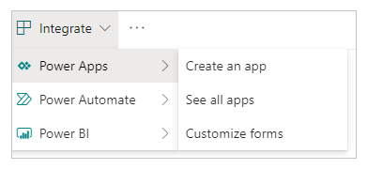

1. Give the app a name, like "Project Requests app", then click or tap **Create**. When the app is ready, it opens in Power Apps Studio.

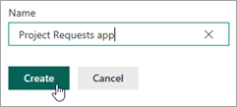

## Step 2: Review the app in Power Apps Studio

1. In Power Apps Studio, the left navigation bar by default shows a hierarchical view of the screens and controls in the app.

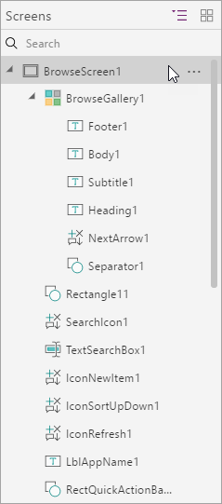

1. Click or tap the thumbnail icon to switch views.



1. Click or tap each screen to view it in the middle pane. There are three screens:

(a). The **browse** screen, where you browse, sort, and filter the data pulled in from the list.

(b). The **details** screen, where you view more detail about an item.

(c). The **edit/create** screen, where you edit an existing item or create a new one.

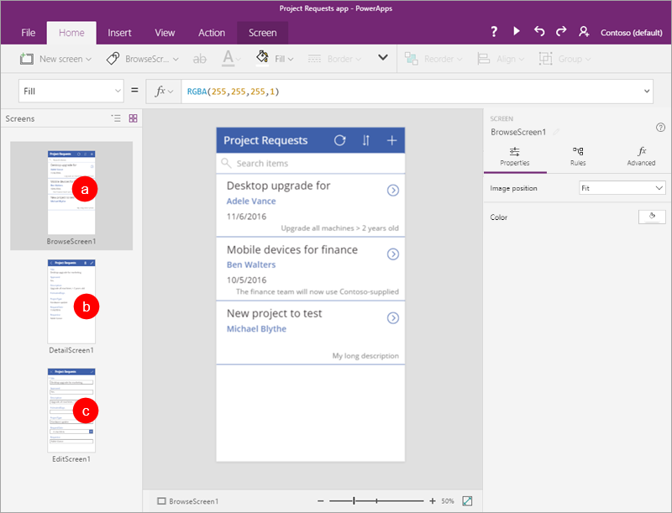

## Step 3: Customize the app's browse screen

1. Click or tap the browse screen.

This screen has a layout that contains a gallery to show list items, as well as other controls, like a search bar and sort button.

1. Select the **BrowseGallery1** gallery by clicking or tapping any record except the first one.

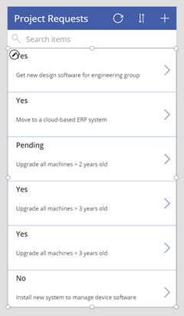

1. In the right pane, under **Properties**, click or tap **Project Requests**.
2. Update the fields to match the following list:
   * **RequestDate**
   * **Requestor**
   * **Title**

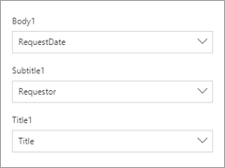

1. With **BrowseGallery1** still selected, select the **Items** property.



1. Change the formula to **SortByColumns(Filter('Project Requests', StartsWith(Title, TextSearchBox1.Text)), "Title", If(SortDescending1, Descending, Ascending))**.



This allows you to sort and search by the **Title** field, instead of the default that Power Apps picked.

1. Click or tap **File**, then **Save**. Click or tap  to go back to the app.

## Step 4: Review the app's details screen and edit screen

1. Click or tap the details screen.

This screen has a different layout that contains a display form to show the details for an item selected in the gallery. It has controls to edit and delete items, and to go back to the browse screen.

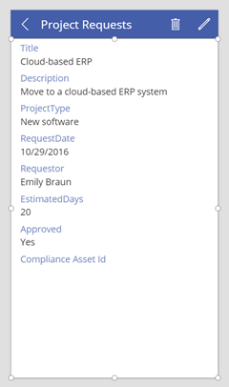

1. Click or tap the edit screen.

This screen contains an edit form to edit the selected item, or create a new one (if you come here directly from the browse screen). It has controls to save or discard changes.

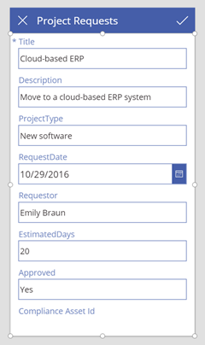

## Step 5: Run the app from the list

1. In the **Project Requests** list, click or tap **All Items**, then **Project Requests app**.

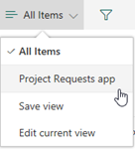

1. Click **Open**, which opens the app in a new browser tab.

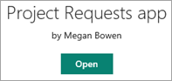

1. In the app, click or tap  for the first item in the browse gallery.



1. Click or tap  to edit the item.
2. Update the **Description** field – change the last word from "group" to "team," then click or tap 

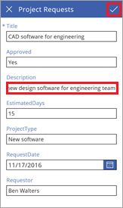

1. Close the browser tab.
2. Go back to the **Project Requests** list, click or tap **Project Requests app**, then **All Items**.

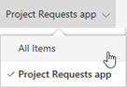

1. Verify the change you made from the app.

